Simple Queue Service (SQS):

Amazon SQS is a highly available distributed queue system

A queue is a temporary repository for messages awaiting for processing and acts as a buffer between the component producer and the consumer

SQS is a message queue service used by distributed applications to exchange messages through a polling model, and can be used to decouple sending and receiving components.

Simple Notification Service(SNS):

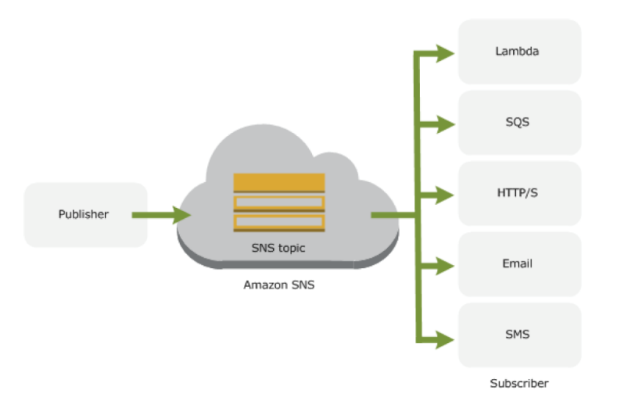

Simple Notification Service – SNS is a web service that coordinates and manages the delivery or sending of messages to subscribing endpoints or clients

SNS provides the ability to create Topic which is a logical access point and communication channel.

Each topic has a unique name that identifies the SNS endpoint for publishers to post messages and subscribers to register for notifications.

Producers push messages to the topic, they created or have access to, and SNS matches the topic to a list of subscribers who have subscribed to that topic, and delivers the message to each of those subscribers

Simple Email Service(SES):

SES is a managed service and ideal for sending bulk emails at scale

SES acts as an outbound email server and eliminates the need to support own software or applications to do the heavy lifting of email transport

Existing email server can also be configure to send outgoing emails through SES with no change in any settings in the email clients

Maximum message size including attachments is 10 MB per message

**SES Characteristics:**

Compatible with SMTP

Applications can send email using a single API call in many supported languages Java, .Net, PHP, Perl, Ruby, HTTPs etc

Optimized for highest levels of uptime, availability and scales as per the demand

Provides sandbox environment for testing